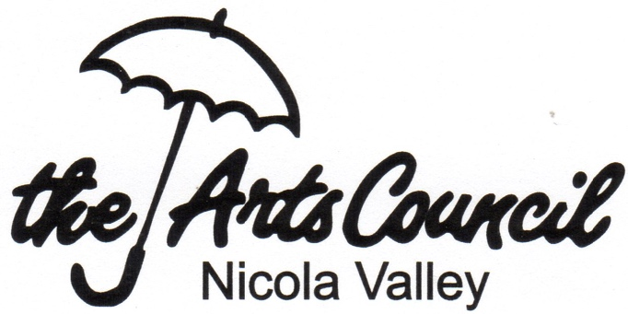
Nicola Valley Community Arts Council
Program Application Form

Thank you for interest in working with the Arts Council.
Please email completed applications to the NVCAC:
nicolavalleyartscouncil@gmail.com using the subject line
“20yy mm dd PAF-title of your project”

Date submitted: 20yy mm dd
Date(s) of Project: 20yy mm dd
Program Title -

Contact: [Name] Phone: [ ] Email: [ ]

Goal(s) of this Program:

Brief description of activities to be undertaken:

This program will be considered successful if:

Planning Timeline, noting important dates and deadlines:

Who is on this Team and what are their roles? (individuals, groups, businesses, other)
- Committee Chair/Team Leader: __________
- Financial management: ______
- Interim and Final Reports: ______
- Other:

Will any professionals be hired/contracted? Yes / No (if Yes, please supply details)

What specific assistance is needed from the NVCAC? (letters of support, Board participation, funding, event liquor license, or in-kind services such as use of our facility, social media and insurance, etc.)

Board consultation completed: Please have your PAF reviewed by our Program Director, Treasurer, and the Director in charge of your project, before submitting it to the Board of Directors for approval

- Program Committee Chair: ____________
- Treasurer: _____________
- Director in charge: _________ (i.e. the Director who reports this Program’s progress to the Board)

Next - complete the Budget page and attach to this submission.

