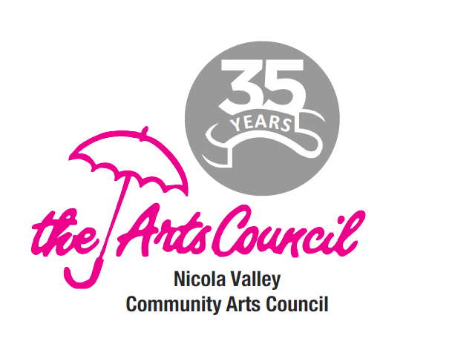
Nicola Valley Community Arts Council

Program Application Form:
Promotion Planning Page

Name of Project/Event:

Organization: Main Contact:

NVCAC Promotion Contact:

Start / Finish Dates: and times:

What | Format | Provide to: | Deadline | Who | Done
Images ready | Digital (jpg) | On request
Text info ready | digital | On request
Design ready | digital | On request
Poster | Printed, distributed | Distribution locations
Press Release | written,  sent by email | Media list
Invitations | Created,  Sent by email | Members, guests
Blog post | Created with image and text | Websites
Facebook post | Created with image and text | Facebook
Social media post | Created with image and text | Twitter, Instagram, etc.
Tickets paper | Info for printing | Merritt Printing
Tickets online | Info for online purchase | CanadaHelps event creation
Interviews | Phone/in person | Media on request
Paid advertising

