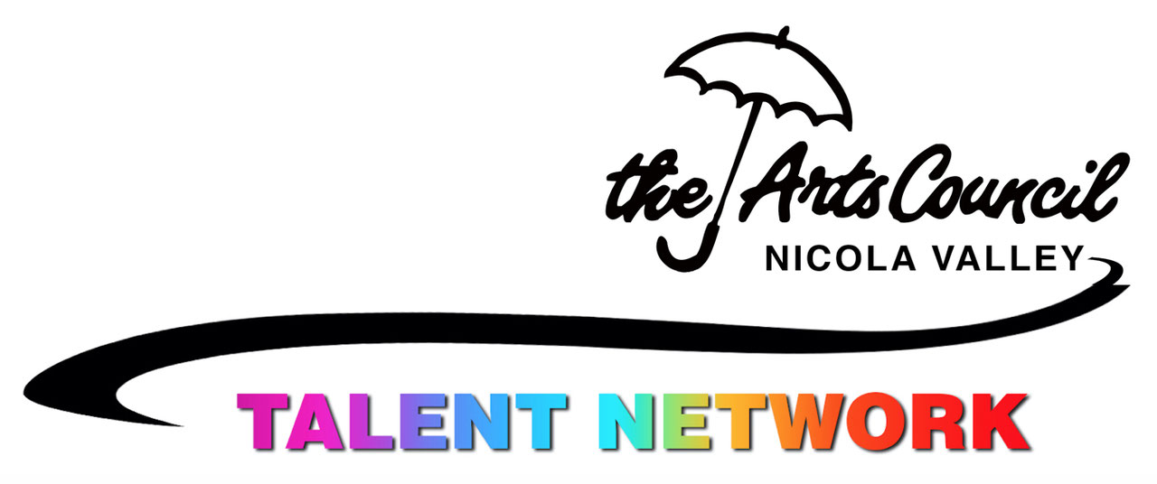
Nicola Valley Community Arts Council https//:nicolavalleyartscouncil.com
nvcac.talent@gmail.com

Attention: Artists, Musicians, Artisans, Writers, Poets, Actors and all other talented folks

We are creating a “Talent Network” to find and promote all the talented people in the Nicola Valley area.
The plan is to create a database of information about the skills and interests that we want to share, whether as a business or a hobby. This growing information set will be a treasure when looking for someone to perform at an event, create a commissioned work, teach a skill, find an instructor, or find others with your interests.

This project has several steps, each with different needs for data, funding, volunteer assistance and decisions.
- Design and Start-up (Dec 2018-Feb 2019)
  - Data: Basic concept work, spreadsheet planning, application form, logo,
  - Funding: “new program” funding from the Nicola Valley Community Arts Council
  - Volunteers: Basic spreadsheet creation, application form, logo creation, recruitment planning
  - Decision: Is this a viable project that could fulfill the objectives? Stop or go?
- Implement (Mar-May 2019)
  - Data: build database from applications, implement social media plan, website, invitations
  - Funding: funding from NVCAC and City of Merritt, plan for ongoing financial stability
  - Volunteers: distribute application forms, social media, promotional events
  - Decision: Is there sufficient interest to create a viable database (minimum 100). Stop or go?
- Manage (June-Aug 2019)
  - Data: continue to collect and add applications, create online resources
  - Funding: membership fees and grants
  - Volunteers: promotion via social media and community events
  - Decision: set 2020 membership fee for ongoing support

Interested?
Info and application forms for the Talent Network are on the NVCAC website and at the Courthouse Arts Centre.

