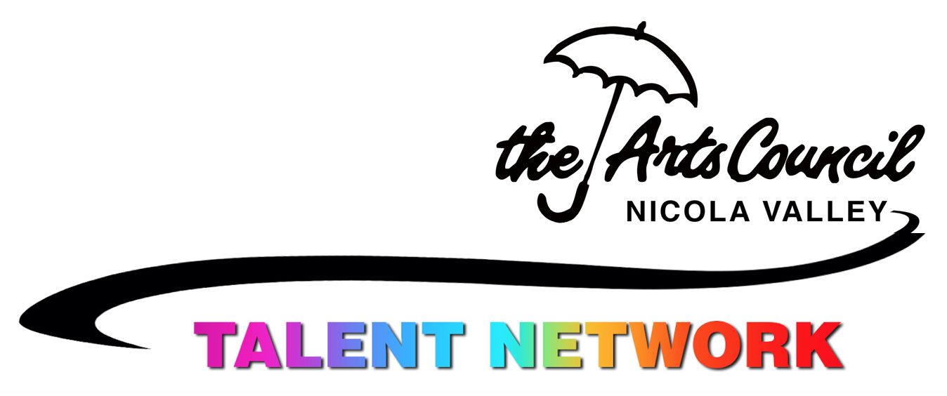
Nicola Valley Talent Network
Application Form
Please ensure you have a current 2019 NVCAC membership and submit this form to
- Courthouse Arts Centre, 1840 Nicola,
- Box 2762, Merritt BC V1K 1B8, or
- Scan or photo to nvcac.talent@gmail.com

Name:
Email:
Phone:
Address:
Your geographic area for municipal voting: Merritt, TNRD-M, TNRD-N, TNRD-other, BC
(This helps us to report to the grant providers who support our programs, including this program.)

Your Online addresses / URLs:
- Website -
- Facebook -
- Instagram -
- Other:

- I request to be included in the Nicola Valley Talent Network program.
- I understand and accept that the Nicola Valley Talent Network and Nicola Valley Community Arts Council may contact me by phone, mail, email and via online social media to provide information and facilitate participation.
- I give permission for my information provided above to be used in the activities of this program, including digital notices and newsletters, texts and messages.
- I understand that digital images of the program’s activities and images I provide may be used in the Nicola Valley Community Arts Council’s printed and online materials for communication, promotion and funding purposes.

Date: Signature:

____________________________________________________________________________
Connect to others with similar interests and with programs and events in your fields. The information you provide on the next page will assist in identifying community needs and resources, e.g. sufficient numbers for a particular workshop or interest group. It may help connect you with others who have similar interests.

If you can help us create community and special activities, please note any particular expertise and interests:

Name: _____________________

- Mark your interest areas below and note any specialties beside it.
- Indicate your personal skill level in each of those by marking them with 1, 2 or 3.
1 = interested/beginner 2 = emerging/intermediate 3 = experienced/professional

Example: 3D - Sculpture - oil clay figures (3), bronze casting (2) stone carving (1)
Dance - Social Dancing - square dance (2) jazz dance (1) ballroom dance (2)

- Visual Arts
  - 2D Drawing/Painting/Multi-media
  - Photography
  - 3D Sculpture, ____
  - Video/film-making
  - Traditional/Cultural
  - Other:
- Music
  - Voice/vocal
  - Instrument
  - Group/Choral
  - Traditional/Cultural
  - Other:
- Dance
  - Social dancing
  - Dance Performance
  - Traditional/Cultural
  - Other:
- Performance
  - Acting
  - Drama
  - Other:
- Literacy
  - Author
  - Poet
  - Playwright
  - Other
- Artisan
  - Fibre Arts
  - Quilting
  - Jewelry
  - Wood
  - Metal
  - Other:
- Do you have a specialty not covered by the above categories? Please describe:

